# 安装shellinabox

1 下载

|  |
| --- |
| sudo wget http://ftp.cn.debian.org/debian/pool/main/s/shellinabox/shellinabox_2.14-1_amd64.deb |

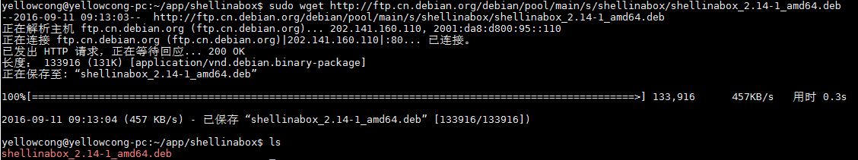

当然你也可以通过apt/yum下载

2 安装

|  |
| --- |
| dpkg -i shellinabox_2.14-1_amd64.deb |

3 修改配置文件/etc/default/shellinabox

|  |
| --- |
| $ sudo vi /etc/default/shellinabox |

配置文件

|  |
| --- |
| # Should shellinaboxd start automatically  SHELLINABOX_DAEMON_START=1  # TCP port that shellinboxd's webserver listens on  SHELLINABOX_PORT=8800  # Parameters that are managed by the system and usually should not need  # changing:  SHELLINABOX_DATADIR=/var/lib/shellinabox  SHELLINABOX_USER=shellinabox  SHELLINABOX_GROUP=shellinabox  # Any optional arguments (e.g. extra service definitions). Make sure  # that that argument is quoted.  #  # Beeps are disabled because of reports of the VLC plugin crashing  # Firefox on Linux/x86_64.  #-s后面指定ssh服务器的地址, 不配置，所有的都可以访问得到  SHELLINABOX_ARGS="--no-beep"  #localhost表示只能本机web登陆  #SHELLINABOX_ARGS="--no-beep -s /:SSH:10.20.111.188 --localhost-only"  •  • # shellinboxd的Web服务器侦听的TCP端口  • SHELLINABOX_PORT=6175  • # 指定目的地SSH服务器的IP地址  • SHELLINABOX_ARGS="--o-beep -s /:SSH:172.16.25.125"  • # 如果你想限制只能从本地主机访问shellinaboxd  • SHELLINABOX_ARGS="--o-beep -s /:SSH:172.16.25.125 --localhost-only" |

我自己的配置，没有配置后面的

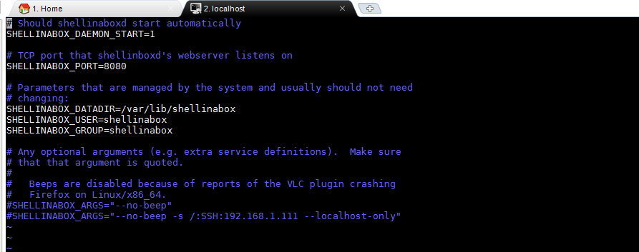

4.启动服务

|  |
| --- |
| sudo service shellinabox start |

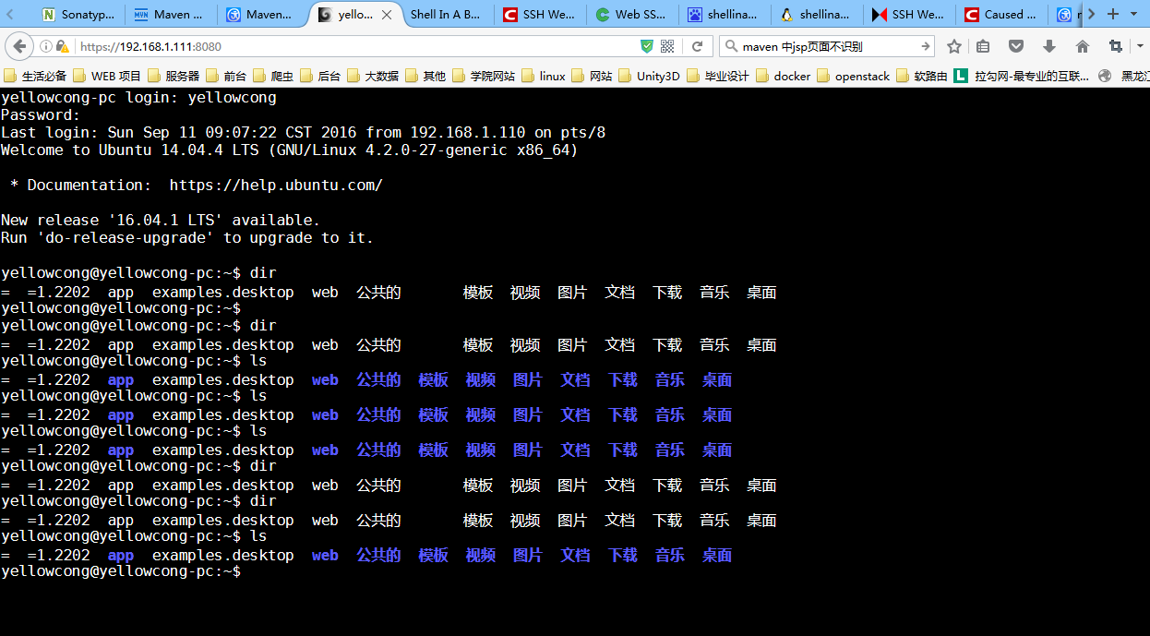

5.问题，不可以安装文件，只可以简单的浏览，不可以输入 sudo apt-get 里面的横杠

浏览器的问题，导致我们不能输入 -（杠）

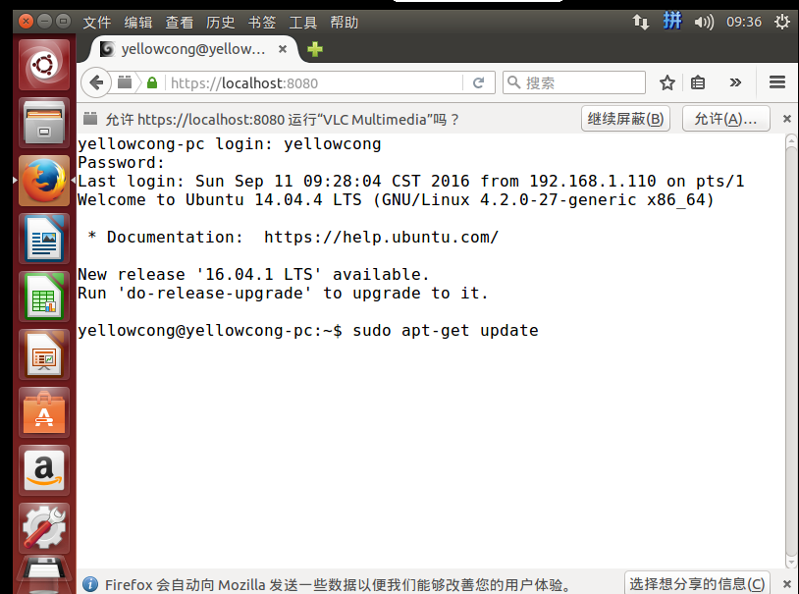

6.配置防火墙，可以访问我们的端口

|  |
| --- |
| sudo netstat -nap | grep shellinabox |

